**Knox Makers Optical Theremin SMT Kit Instructions**

**Learn Surface Mount Soldering!**

November 2020

Surface mount technology uses physically small components that allow for smaller assemblies, higher performance circuits, access to modern integrated circuits and cool factor among your maker friends. Thru-hole component technology was enough to put us on the moon but relatively few modern components are offered in thru-hole technology. Also, these days we are accustomed to smaller, more portable circuits. Surface Mount Technology (SMT) using Surface Mount Devices (SMD) can open up a wide array of possibilities to the electronics enthusiast. The terms SMT and SMD are used interchangeably to refer to the technological processes of working with surface mount components, and to refer to the components themselves.

**Intro to Surface Mount Soldering**

**Surface mount soldering irons**

To solder these smaller components, a soldering iron where temperature can be set in degrees (not just a vague number like 1-10) is highly desirable and fine point replaceable tips are pretty much a must for anything other than occasional soldering of the largest SMT parts. A common rule of thumb is that the tip of the soldering iron should be of similar size as the pad of the component you are soldering. From a practical perspective a 1/16” to 1/8” tip can handle a wide range of SMT components.

**Surface mount solder**

There are strong opinions out there when it comes to “what solder should I use”, much like asking car guys which oil is best. Truly, it doesn’t matter, they all work. Use something designated for electronics, not plumbing. Now, some details, and remember, don’t overthink this, just go solder.

A small diameter SnPb wire solder is recommended. 0.015” will work well with a wide range of SMT components. 0.03” to 0.04” can be used with larger components but can be difficult to get nice looking results.

Lead (Pb) or lead-free (Pb-free) solder? Both perform equally well. Most people find lead-free easier to use, though with practice they are fairly close to each other. Much of what you read on the internet may be tainted by experiences from when lead-free solder was first developed. Metallurgy has progressed since then and lead-free solders are easier to use now. That said, most folks recommend solder with Pb to start.

People are often concerned with Pb exposure when soldering. The most likely internal exposure to Pb is ingestion due to your hands becoming contaminated from handling solder, from dust, and from “dross”- fine particles of Pb that can be generated while soldering and then end up on the hands. If you then chew your fingernails or eat food without washing your hands, you can ingest Pb. Fumes are not a concern for the home enthusiast using proper soldering temperature. Solder work is typically performed at less than 750°F while Pb fumes are generated in significant quantities at temperatures closer to 840°C. So, keep your temperatures where they should be and wash your hands.

Solder includes a flux core in the middle of it. This flux generates the smoke you see when people are soldering and it can be a lung irritant to some people. If you solder daily or find it irritating then a fan or fume extractor might be a good investment though many never find it necessary.

**Soldering Temperature**

Temperature settings vary based on the particular solder iron, the tip used, the component being soldered, the PCB layout being soldered to and technique. Generally speaking, lower temperature is preferred to higher temperature and faster soldering times are preferred to slower ones. The main reason for this is to minimize how much heat is transferred to the device being soldered and to the pads and traces on the PCB itself. Overheating the component can melt internal plastics (e.g. switches and jacks) and can even damage components like integrated circuits. 10 seconds of heat is fine, 30 seconds is probably fine, but don’t push it. Overheating or repeated heating of PCB pads and traces can cause them to delaminate, lifting off the PCB. Reheating a pad 5 to 7 times is probably fine. Play with your temperature setting to find what gives you a nice result with minimum soldering time. 750°F is a good starting point. 730°F to 760°F is common but those are loose numbers, use what works for you and don’t worry about it too much though 800°F is getting pretty hot. Lead-free soldering tends to need slightly higher temperatures than Pb solder.

Fine point tweezers are a must have. They don’t need to be expensive, and be careful with them. One drop on their tips will bend them, likely beyond good repair.

The last thing you probably need is some type of optical magnification. 3x to 7x is a good range to be in. 3x can be too little for some people or for smaller components but 7x can also feel cramped with visor magnifiers due to their short working distance. Focal distance or working distance refers to the distance between the lens and the workpiece. 4” can feel cramped, 8” is very comfortable. You get what you pay for with optics. Very good visor magnifiers (a la Donegan OptiVisor can be had for around $50). Some prefer digital microscopes (digital cameras on a stand) which can be < $100. Low magnification lamps are only good enough for those with great eyesight or the largest SMT components. An optical microscope can be very nice but new can cost $400--$500.

Small solder braid can be helpful for cleaning up joints.

**Handling SMT components**

SMT components typically come in cut tape form or in small containers. When pulling tape and removing components, it’s easy to accidentally shoot the part across the desk, onto the floor, never to be found again. Work slowly and be careful.

When placing a component with tweezers, it’s easy for the component to shoot out of the tweezers, across the desk, onto the floor, never to be found again. This is likely to happen now and again, no matter how long you’ve done SMT soldering. Some components, like resistors, are usually easier to handle due to their having nicely squared edges. Capacitors and diodes usually have more rounded edges and quite easily fly out from between tweezer tips.

**Soldering technique**

There are multiple ways to solder SMT components. A typical SMT resistor or capacitor is soldered by first putting a small bump of solder on one of the PCB pads and then reheating that bump of solder while pushing the SMT component into the wet solder and against the solder iron tip until the solder flows nicely along the component. Ideally this results in a nice, clean fillet between the component and the pad. Then the other side is soldered. Finally, the first pad is sometimes reflowed a second time to clean up the joint.

If solder doesn’t want to flow, a bit of flux from a flux pen or other dispenser may do the trick.

Watch some online videos for some good demonstrations.

**Kit Assembly**

**Start with the fixed resistors (Figure 1)**

The largest, and easiest SMT parts in this kit are the 1206 resistors. 1206 refers to the case size which is 120mil x 60mil, or 0.120” x 0.060”. Larger resistors usually have labels on them that describe their resistance. The image and table below show examples. AA is the ohms prefix, B is the number of zeros after it.

AAB

|  |  |
| --- | --- |
| **Marking** | **Value** |
| 102 | 1,000 Ω or 1 kΩ |
| 103 | 10,000 Ω or 10 kΩ |
| 220 | 22Ω |
| 1R0 | 1.0Ω |

The 3 fixed resistors, R1, R2, R4, all are 1k and are marked as “102”. Solder them first and then solder R7 (100Ω, marked “101”).`

**Next the trimmer resistors (Figure 1)**

R3 and R5 are trimmer resistors, or variable resistors. They can only be soldered to the PCB in one orientation. Tack them down with one pad, solder the other two pads, then reflow the first pad.

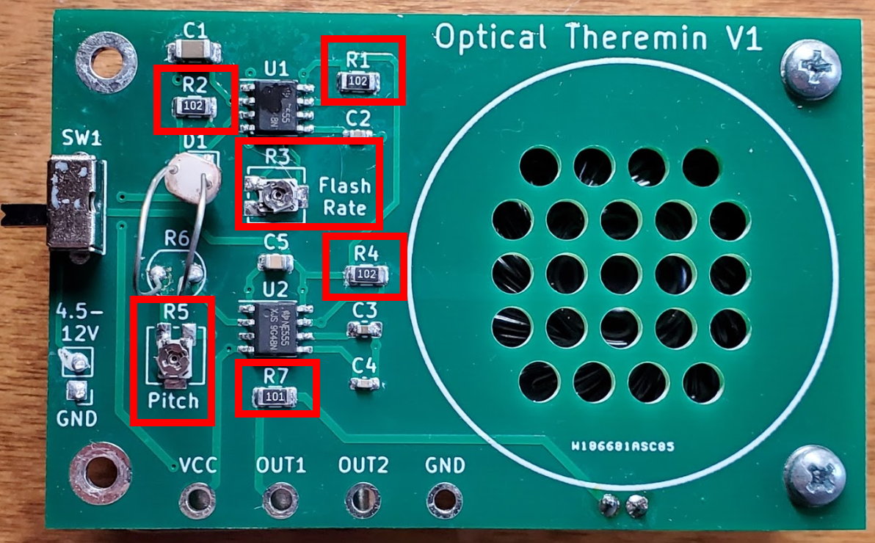

**Figure 1: Resistor Locations**

**Now the capacitors (Figure 2)**

C1 is a 10µF capacitor. Capacitors aren’t usually labeled on the body but the bag or strip or container it’s in may be marked “106” which, like the resistor marking code, means 10 followed by 6 zeros, and is in pF (10-9 farads): 10,000,000pF = 10µF. This is a 1206 size capacitor, and is of like size to the fixed resistors but taller. Solder that one next.

C3 and C5 are a little smaller – 0805 size, or 0.08” x 0.05”. This is still fairly large by SMT standards but is quite small compared to most thru-hole components. These are both 0.1µF capacitors and may be in a bag labeled 104 (100,000pF or 0.1µF). Solder these next.

C2 and C4 are the most challenging components in this kit. They are 0603 size, or 0.06” x 0.03”. Many who are new to SMT work find these intimidating and some never attempt them. They aren’t as hard as they look and with the earlier practice you should be OK. Carefully solder them next.

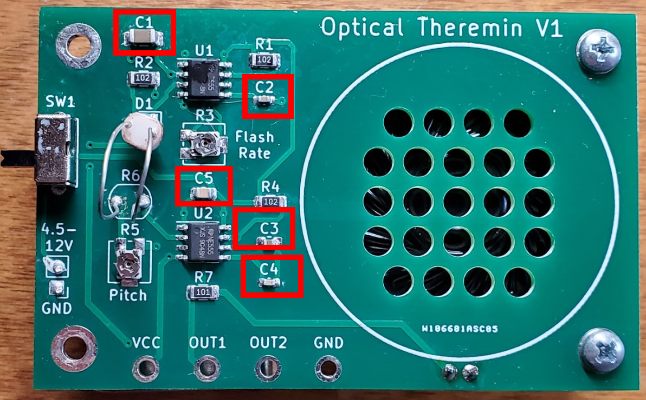

**Figure 2: Capacitor Locations**

**The LED (Figure 3)**

The diode can be accidentally soldered in backwards so be very careful with this component. Figure 3 shows a mounted diode on top and underneath shows a second diode in the same orientation, from the back.

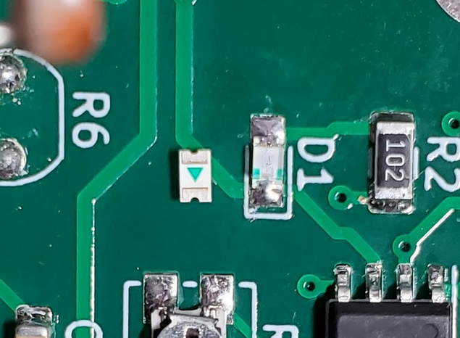

**Figure 3: LED Orientation**

**The ICs (Figure 4)**

The ICs are the brains of this operation. These could be accidentally soldered in backwards so pay attention to the small circular indentation on the IC package and the white silk screen line on the PCB for correct orientation. Tack down one of the corner leads such that the other IC leads fall on their respective pads. Then tack down the opposite corner lead. Then solder the remaining leads and reflow the first two.

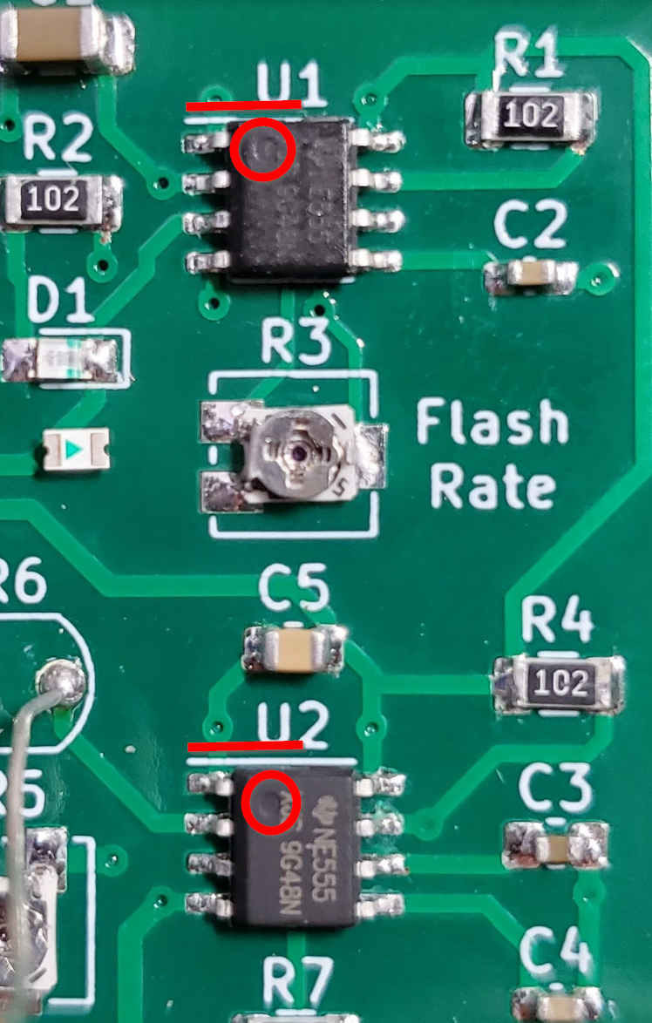

**Figure 4: IC Orientation**

**Thru-hole components**

The hard work is done (maybe). Now, solder the switch in place and then the LDR (labeled R6 on the PCB). The LDR is a resistor whose value varies with light that is shining on it. Solder the LDR so that the leads barely poke through the PCB and it stands up in the air well off the board. We will be bending and flexing this around to change the sounds the circuit makes.

**Speaker**

The speaker is first hot glued onto the back of the PCB, roughly centered over the holes so sound can get through. Once it’s soldered in place, solder the two leads attached to it into the two nearby holes in the PCB. There is no polarity, either wire can go in either hole.

**9V Battery**

Next trim the leads on the 9V battery clip so they are ~2” long. When soldering these leads into the PCB pay attention to the polarity. The black lead solders to the hole labeled “GND”, the red lead to the hole labeled “4.5V-12V”.

Plug the battery into the battery clip and hot glue the battery to the back of the PCB. You’re done!

**Turn it on!**

The theremin is the circuit around U2 including the LDR. The light that shines on that LDR sets the frequency of the oscillation (the audible tone). More light results in higher frequency. You can point the LDR directly upwards and move your hands closer and further from the LDR to play with this effect.

The circuit around U1 is simply an LED flashing circuit which is another light source you can use as desired. By bending the LDR so that more or less of the LED light reaches it, you can impart a vibrato on top of the tone generated by background lighting.

You can move your fingers or hands between the LED and the LDR and ambient light and the LDR. Also play with the distance of the LDR to the LED. Enjoy!

**Debugging**

The board has two separate circuits in it: the LED flashing circuit and the audible tone generation circuit. If the LED is flashing and the rate of flashing can be varied by turning R3 with a small screwdriver, then the components around U1 are probably all OK. If a tone is playing out the speaker and it can be adjusted by turning R7 then that circuit is probably working OK.

If neither circuit is working then look for voltage of ~9V across the battery terminals itself. Check the polarity of the battery clip wires (red and black to the right holes). You should see ~9V across the two solder joints where the battery clip attaches to the PCB. With the switch in the on (up) position there should be ~9V across the two terminals of C5. If not then something is wrong with the switch itself or its soldering to the PCB.

Once you confirmed battery voltage is getting to C5 then debug the LED flashing circuit (U1, R1, R2, R3, C1, C2, D3). Check the orientation of U1 and D1. Then reflow the solder joints of each component. This should fix any problem and the LED should be flashing. If the LED is on but appears dim it might just be flashing very quickly. Adjust R3 clockwise to slow the rate of flashing down.

Once you have the LED flashing let’s get the tone gerator working. Check orientation of U1. Then reflow each of the other components. Check that the speaker wires are well connected to the pcb and the speaker terminals.

**Theory of Operation**

U1 and its associated components (R1, R2, R3, C1, C2, D1). form a simple LED flashing circuit. You can find many similar examples of this circuit with detailed explanations of operation online. R1, R3, C1 and C2 determine the frequency of oscillation. D1 is the visible LED and R1 sets the LED’s brightness.

U2 and its associated components (R4, R5, R6, R7, C3, C4, Speaker) form an audio oscillator.R4, R5, R6, C3 and C4 set the frequency of oscillation. R5 varies with incident light intensity which varies the frequency of oscillation. R7 sets the volume of the speaker.

C5 is a supply bypass capacitor. It is probably unnecessary with only a battery powering it but could be useful if an external supply of some sort is used.

**Bill of Materials**

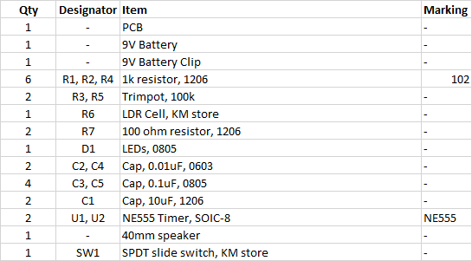

**PCB Layout**

